A PROJECT REPORT ON
ZERO-KNOWLEDGE PROOF BASED
PRIVACY COMPLIANCE SYSTEM
(A Blockchain-Anchored Framework for Privacy-Preserving Regulatory Compliance Verification)
Submitted in partial fulfillment of the requirements for the degree of
BACHELOR OF TECHNOLOGY
IN
COMPUTER SCIENCE AND ENGINEERING
(ARTIFICIAL INTELLIGENCE & MACHINE LEARNING)
Submitted by:
K. Prem Kumar (23RA1A6675)
N. Rakesh Chary (23RA1A6682)
K. Shivamani (23RA1A66A6)
G. Shashank (23RA1A6693)
Under the Guidance of:
Dr. M. Chalapathi Rao
Department of Computer Science and Engineering (AI & ML)
DEPARTMENT OF COMPUTER SCIENCE AND ENGINEERING (AI&ML)
KOMMURI PRATAP REDDY INSTITUTE OF TECHNOLOGY, HYDERABAD

ACADEMIC YEAR: 2026 – 2027


Kommuri Pratap Reddy Institute of Technology
Department of Computer Science and Engineering (Artificial Intelligence & Machine Learning)

Vision of the Institute :
To emerge as a premier institute for high quality professional graduates who can contribute to economic and social developments of the Nation.

Mission of the Institute:

Mission | Statement
IM1 | To have holistic approach in curriculum and pedagogy through industry interface to meet the needs of Global Competency.
IM2 | To develop students with knowledge, attitude, employability skills, entrepreneurship, research potential and professionally Ethical citizens.
IM3 | To contribute to advancement of Engineering & Technology that would help to satisfy the societal needs.
IM4 | To preserve, promote cultural heritage, humanistic values and Spiritual values thus helping in peace and harmony in the society.

Kommuri Pratap Reddy Institute of Technology
Department of Computer Science and Engineering (Artificial Intelligence & Machine Learning)

Vision of the Department:

To be a premier center of excellence with research in Artificial Intelligence and Machine Learning research through unique interdisciplinary partnerships and positive contribution to the students, community, organizations and society as a whole.

Mission of the Department:

Mission | Statement
DM1 | To impart knowledge in cutting edge Artificial Intelligence technologies in par with industrial standards.
DM2 | To collaborate with industry to uplift innovative research and development in Artificial Intelligence and Machine Learning and its allied fields to serve the needs of society.
DM3 | To produce successful Computer Science and Engineering graduates with a specialization in AIML with personal and professional responsibilities and commitment to lifelong learning.

Kommuri Pratap Reddy Institute of Technology
Department of Computer Science and Engineering (Artificial Intelligence & Machine Learning)

Program Educational Objectives (PEOs) :

PEO’s | Statement
PEO1 | Demonstrate technical skills, competency in AI & ML and exhibit team management capability with proper communication in a job environment.
PEO2 | Support the growth of economy of a country by starting enterprise with a lifelong learning attitude.
PEO3 | Carry out research in the advanced areas of Al & ML and address the basic needs of the society.
PEO4 | To develop research attitude among the students in order to carry out research in cutting-edge technologies, solve real world problems and provide technical consultancy services.

Kommuri Pratap Reddy Institute of Technology
Department of Computer Science and Engineering (Artificial Intelligence & Machine Learning)

PROGRAM OUTCOMES

PO1 | Engineering Knowledge: Apply the knowledge of mathematics, science, Engineering fundamentals, and an engineering specialization to the solution of complex engineering problems.
PO2 | Problem Analysis: Identify, formulate, review research literature, and analyze complex engineering problems reaching substantiated conclusions using first principles of mathematics, natural sciences, and engineering  sciences.
PO3 | Design/development of Solutions: Design solutions for complex engineering problems and design system components or processes that meet the specified needs with appropriate consideration for the public health and safety, and the cultural, societal, and environmental considerations.
PO4 | Conduct investigations of complex problems: Use research-based knowledge and research methods including design of experiments, analysis and interpretation of data, and synthesis of the information to provide valid  conclusions.
PO5 | Modern tool usage: Create, select, and apply appropriate techniques, resources, and modern engineering and IT tools including prediction and modeling to complex engineering activities with an understanding of  the limitations.
PO6 | The engineer and society: Apply reasoning informed by the contextual knowledge to assess societal, health, safety, legal and cultural issues and the consequent responsibilities relevant to the professional engineering  practice.
PO7 | Environment and sustainability: Understand the impact of the professional engineering solutions in societal and environmental knowledge of, and need for sustainable development.
PO8 | Ethics: Apply ethical principles and commit to professional ethics and responsibilities and norms of the engineering practice.

PO10 | Communication: Communicate effectively on complex engineering activities with the engineering community and with society at large, being able to comprehend and write effective reports and design documentation, make Effective presentations, and give and receive clear instructions.
PO11 | Project management and finance: Demonstrate knowledge and understanding of the engineering and management principles and apply these to one’s own work,as a member and leader in a team, to manage projects and in multidisciplinary environment.
PO12 | Life-Long learning: Recognize the need for, and have the preparation and able to engage in independent and life-long learning in the broadest context of technological change.
PO9 | Individual and team network: Function effectively as an individual, and as a member or leader in diverse teams, and in multidisciplinary settings.

PROGRAM SPECIFIC OUTCOMES

PSO1 | Demonstrate the knowledge of human cognition, Artificial Intelligence, Machine Learning and data engineering for designing intelligent systems.
PSO2 | Apply computational knowledge and project development skills to provide innovative solutions.
PSO3 | Use tools and techniques to solve problems in AI & ML.

TABLE OF CONTENT
CHAPTER 1: ABSTRACT 10
1.1 Abstract 10
1.2 Keywords 10
CHAPTER 2: INTRODUCTION 11
2.1 Overview 11
2.2 Research Motivation 11
2.3 Research Objectives 11
2.4 Project Scope 12
2.5 Significance 12
2.6 Advantages 12
2.7 Applications 13
2.8 Expected Outcomes 13
CHAPTER 3: LITERATURE REVIEW 14
3.1 Survey of Related Literature 14
3.2 Detailed Analytical Review of Literature 15
3.3 Research Gap Analysis 15
CHAPTER 4: PROBLEM STATEMENT 17
4.1 Problem Overview 17
4.2 Formal Problem Statement 17
4.3 Constraints and Assumptions 17
CHAPTER 5: EXISTING SYSTEM 18
5.1 Traditional Systems 18
5.2 Limitations of Existing Systems 18
5.3 Existing vs. Proposed System 18
CHAPTER 6: PROPOSED SYSTEM 20
6.1 Overview 20
6.2 Approach and Workflow 20
6.3 Zero-Knowledge Compliance Model 20
6.4 Consent Lifecycle Management 20
6.5 Blockchain Anchoring and Certification 21
6.6 Security, Privacy and Regulatory Alignment 21
6.7 Validation Plan 21
6.8 Advantages and Limitations 21
CHAPTER 7: HARDWARE REQUIREMENTS 23
7.1 Development and Host Workstation 23
7.2 Application and Proof-Generation Server 23
7.3 Client Workstation 23
CHAPTER 8: SOFTWARE REQUIREMENTS 24
8.1 Technology Stack 24
8.2 Software Dependencies and Configuration 24
CHAPTER 9: SYSTEM ARCHITECTURE 25
9.1 Overview 25
9.2 Five-Layer Architecture 25
9.3 How the Layers Interact 26
9.4 Architecture Component Explanation 26
9.5 End-to-End Data Flow 26
9.6 Data Flow Diagram Level 0 27
9.7 Data Flow Diagram Level 1 28
CHAPTER 10: MODULES 29
10.1 Module Overview 29
10.2 M1: Data Input and Preprocessing 29
10.3 M2: ZKP Circuit and Proof Generation 29
10.4 M3: Blockchain Smart Contract 29
10.5 M4: Verification and Compliance Dashboard 29
10.6 Module Interaction and Interface Contracts 30
CHAPTER 11: UML DIAGRAMS 31
11.1 Use Case Diagram 31
11.2 Activity Diagram 32
11.3 Sequence Diagram 33
11.4 Class Diagram 33
11.5 Component Diagram 34
11.6 Deployment Diagram 35

CHAPTER 1: ABSTRACT

1.1 Abstract
Organizations that process personal data are increasingly required to demonstrate compliance with data-protection regulations such as India’s Digital Personal Data Protection Act, 2023 (DPDPA). Conventional compliance audits, however, force an organization to expose raw personal and financial records to auditors and regulators, which creates breach risk and dependence on a trusted central party. Consent records kept in centralized databases or spreadsheets are also easy to alter silently, so a claim that valid consent was obtained is difficult to trust or independently verify.
This project presents a Zero-Knowledge Proof Based Privacy Compliance System, a blockchain-anchored framework that replaces “show us the data” with “prove the rule holds.” Each compliance rule (for example, valid consent, a KYC/AML threshold or a data-handling constraint) is encoded as an arithmetic circuit in Circom. The data owner generates a zk-SNARK proof (Groth16) with snarkjs showing that the rule is satisfied without revealing the underlying inputs. The proof and its public signals are submitted to a verifier smart contract on the Algorand TestNet, which checks the proof and anchors the proof hash and verification result on an immutable ledger. Personal identifiers are hashed or encrypted before storage and remain in an encrypted off-chain store that is never written to the chain.
The system follows a five-layer architecture (React.js presentation layer, Node.js/FastAPI application layer, Circom and snarkjs ZKP engine, smart-contract blockchain layer, and an encrypted PostgreSQL/MongoDB storage layer) and is organised into four independently testable modules: Data Input and Preprocessing, ZKP Circuit and Proof Generation, Blockchain Smart Contract, and Verification and Compliance Dashboard. A regulator-facing portal provides proof verification, an audit trail, real-time compliance analytics and blockchain-backed compliance certificates. The project is an academic prototype that supports a selected set of compliance predicates; it is a technical verification framework and not an official legal certification of compliance.

1.2 Keywords
Zero-Knowledge Proofs, zk-SNARK, Groth16, Circom, snarkjs, Algorand, Blockchain, Privacy Compliance, DPDPA 2023, Consent Management, Smart Contracts, Data Minimization.

CHAPTER 2: INTRODUCTION

2.1 Overview
Personal data now underpins banking, healthcare, e-commerce and public services, and governments have responded with stricter data-protection regimes. In India, the Digital Personal Data Protection Act, 2023 (DPDPA) places consent-based processing obligations on organizations (Data Fiduciaries) that handle the personal data of individuals (Data Principals). Comparable frameworks include the European Union’s GDPR, which emphasizes data minimization, and the United States HIPAA rules, which apply a minimum-necessary standard. Regulators and business partners therefore routinely ask organizations to prove that consent was validly obtained and that data-handling rules are followed before data can be trusted or shared.
Proving compliance today usually means handing over the very data the regulation is meant to protect. Auditors inspect raw records, consent logs are kept in mutable databases, and verification is slow, manual and opaque. This is the central paradox addressed by the project: privacy and proof appear to pull in opposite directions, because proving a fact about data seems to require revealing the data.
Zero-knowledge proofs (ZKPs) resolve this paradox. Introduced by Goldwasser, Micali and Rackoff, a zero-knowledge proof lets a prover convince a verifier that a statement is true without revealing anything beyond its validity. A zk-SNARK (Zero-Knowledge Succinct Non-interactive Argument of Knowledge) packages such a proof into a small, non-interactive object that can be verified quickly. When the verifier is a smart contract and the result is recorded on a blockchain, the outcome becomes a tamper-evident, publicly checkable attestation. The proposed system combines these ideas: compliance rules are encoded as circuits, proofs are generated by the data owner, verification is performed on the Algorand blockchain, and regulators read the immutable result without ever seeing the underlying personal data.

2.2 Research Motivation
Three observations motivate this work. First, data-protection law is expanding faster than the tooling used to audit it, so compliance evidence is increasingly assembled by hand. Second, centralized consent databases are single points of failure: a breach or an insider edit can invalidate the evidence that an organization relies on. Third, the cryptographic and blockchain building blocks needed for a better approach (succinct proofs, programmable ledgers with instant finality) have matured to the point where an end-to-end prototype is feasible for a student project.
The project therefore aims to demonstrate that compliance can be proved cryptographically and anchored immutably, so that a regulator is convinced of a rule’s satisfaction without being given access to confidential user data, and so that organizations lower both their audit effort and their data-exposure risk.

2.3 Research Objectives
The primary objectives established for this project are:
1. Privacy-Preserving Compliance Verification: Enable verification of compliance under India’s DPDPA, 2023 without exposing raw personal data to regulators or auditors.
2. Automated ZK Proof Generation: Build a pipeline in which compliance rules are expressed as Circom circuits and Groth16 proofs are produced automatically with snarkjs.
3. Immutable Audit Trail: Anchor proof hashes and verification results on the Algorand blockchain through a verifier smart contract so that every compliance check is tamper-evident and timestamped.
4. Consent Lifecycle Management: Support the full consent lifecycle (capture, update, withdrawal and expiry) with hashed identifiers so that raw data never touches the system unprotected.
5. Regulator Portal and Analytics: Deliver a regulator-facing verification portal with proof-status queries, audit-trail reports, real-time compliance analytics and blockchain-backed compliance certificates.
6. Secure Data Handling: Apply encryption of off-chain private data, role-based access control and strict data minimization so that only proof hashes and public signals reach the chain.
7. Modular, Interface-Driven Design: Decompose the system into four modules with explicit interface contracts so that they can be built and unit-tested in parallel.
8. Extensibility: Provide a scalable framework that can be extended to additional compliance predicates and to future data-protection regulations.

2.4 Project Scope
The boundaries of the work agreed during the project reviews are summarized in Table 2.1. The prototype targets selected compliance predicates on a test blockchain network; it is a web platform in this phase.
In Scope | Out of Scope
Consent lifecycle management for personal-data processing | Official government / legal DPDPA certification or accreditation
ZK-SNARK proof generation for validating consent records and compliance rules | Cross-border regulatory compliance beyond India’s DPDPA
Algorand blockchain integration for anchoring proof hashes | Deep integration with third-party enterprise ERP systems
Regulator verification portal and compliance certificates | Native mobile application (web platform only in this phase)
Real-time compliance analytics dashboard | Support for regulations outside the data-privacy domain
Table 2.1: Project scope

2.5 Significance
Academically, the project operationalizes zero-knowledge cryptography, which is usually studied in the abstract, as a complete software-engineering pipeline from circuit design to on-chain verification. Technically, it shows how a succinct proof system, a smart contract and a conventional web stack can be integrated into one auditable workflow. From a regulatory-technology standpoint, it moves compliance evidence from “trust the organization’s records” to “verify the mathematics,” reducing dependence on a trusted central party. From a privacy standpoint, it demonstrates data minimization by construction, because the regulator never receives the private inputs at all.

2.6 Advantages
- Privacy by Construction: Proofs reveal nothing beyond the validity of the compliance statement; raw data stays with the owner or in the encrypted off-chain store.
- Tamper-Proof Auditability: The blockchain ledger gives an immutable, timestamped trail of every compliance check performed.
- Trust Minimization: The verifier trusts the cryptographic proof itself, not the data owner and not a central authority.
- Reduced Audit Effort: Automated proof generation and on-chain verification reduce manual verification time and overhead.
- Real-Time Oversight: The regulator dashboard provides live proof status and analytics rather than periodic manual reports.
- Modularity: Each layer and module owns a single responsibility behind a narrow interface, so components can be replaced or tested independently.
- Extensibility: New compliance rules are added as new circuits without redesigning the rest of the platform.

2.7 Applications
1. DPDPA Consent Compliance: Letting Data Fiduciaries prove that valid, unexpired and unwithdrawn consent exists for a processing purpose without disclosing the Data Principal’s identity or record.
2. KYC / AML Threshold Verification: Proving that an income, age or transaction value satisfies a regulatory threshold without revealing the exact figure.
3. Healthcare Data Sharing: Supporting minimum-necessary disclosure by proving eligibility or consent without releasing patient records.
4. Data-Minimization Attestation: Providing partners and regulators with verifiable evidence of data-handling rules under frameworks such as GDPR.
5. Third-Party Processor Audit: Allowing data fiduciaries to demonstrate processor compliance to supervisory authorities with a verifiable on-chain record.
6. Regulatory Analytics: Supplying supervisory bodies with aggregate, verifiable compliance dashboards across many entities.
Crucial Operational Notice: The system is a technical framework for privacy-preserving verification. It does not replace legal advice, statutory certification or the judgement of a competent authority, and any production deployment would require legal review and a formal security audit.

2.8 Expected Outcomes
- A working prototype demonstrating the end-to-end ZK-proof compliance flow, from private input to an on-chain attestation.
- Reduced compliance-audit time and manual verification overhead.
- Stronger trust and transparency between organizations and regulators.
- A scalable framework extensible to future data-protection regulations.

CHAPTER 3: LITERATURE REVIEW

3.1 Survey of Related Literature
The project sits at the intersection of zero-knowledge cryptography, blockchain-based privacy and consent management, and regulatory compliance. Table 3.1 summarizes the principal contributions that inform the design.
S.No | Paper Title & Authors | Year & Venue | Methodology & Contribution | Limitations & Relevance
1 | The Knowledge Complexity of Interactive Proof Systems  S. Goldwasser, S. Micali, C. Rackoff | 1989  SIAM J. Comput. | Introduced zero-knowledge proofs: a prover can convince a verifier that a statement is true while revealing nothing beyond its validity. | Limit: Interactive and theoretical; no practical deployment path.  Rel: Foundational definition of the zero-knowledge property used throughout the project.
2 | Quadratic Span Programs and Succinct NIZKs without PCPs  R. Gennaro, C. Gentry, B. Parno, M. Raykova | 2013  EUROCRYPT | Showed how computations can be encoded as quadratic arithmetic programs, giving short non-interactive proofs that are fast to verify. | Limit: Requires a trusted, circuit-specific setup.  Rel: Basis for expressing compliance rules as arithmetic circuits.
3 | Pinocchio: Nearly Practical Verifiable Computation  B. Parno, J. Howell, C. Gentry, M. Raykova | 2013  IEEE S&P | Built an end-to-end system compiling programs to circuits with constant-size proofs and fast public verification. | Limit: Proving cost grows with circuit size.  Rel: Motivates the compile-prove-verify pipeline realized with Circom and snarkjs.
4 | On the Size of Pairing-based Non-interactive Arguments  J. Groth | 2016  EUROCRYPT | Presented the Groth16 zk-SNARK with very small proofs (three group elements) and a pairing-based verification check. | Limit: Per-circuit trusted setup; toxic-waste risk if the ceremony is compromised.  Rel: The proof system adopted by this project.
5 | Zerocash: Decentralized Anonymous Payments from Bitcoin  E. Ben-Sasson, A. Chiesa, C. Garman, M. Green, I. Miers, E. Tromer, M. Virza | 2014  IEEE S&P | Applied zk-SNARKs to a ledger so that transactions are verified publicly without revealing sender, receiver or amount. | Limit: Focused on payments, not regulatory compliance.  Rel: Demonstrates zk-SNARK verification anchored on a blockchain.
6 | Hawk: The Blockchain Model of Cryptography and Privacy-Preserving Smart Contracts  A. Kosba, A. Miller, E. Shi, Z. Wen, C. Papamanthou | 2016  IEEE S&P | Proposed a framework in which smart contracts keep private data off-chain while the chain enforces correct execution using zero-knowledge proofs. | Limit: Relies on a trusted manager for some privacy properties.  Rel: Supports the off-chain private data and on-chain verification split.
7 | Decentralizing Privacy: Using Blockchain to Protect Personal Data  G. Zyskind, O. Nathan, A. Pentland | 2015  IEEE S&P Workshops | Proposed a blockchain-based access-control manager so that users own and control their personal data. | Limit: Stores access-control metadata but does not prove rule compliance without disclosure.  Rel: Motivates blockchain-backed consent and audit records.
8 | MedRec: Using Blockchain for Medical Data Access and Permission Management  A. Azaria, A. Ekblaw, T. Vieira, A. Lippman | 2016  OBD Conference | Used smart contracts to manage patient permissions and an auditable record of data access in healthcare. | Limit: Does not give regulators a privacy-preserving verification mechanism.  Rel: Shows a consent and permission ledger in a regulated domain.
9 | Algorand: Scaling Byzantine Agreements for Cryptocurrencies  Y. Gilad, R. Hemo, S. Micali, G. Vlachos, N. Zeldovich | 2017  ACM SOSP | Described a pure proof-of-stake blockchain with fast finality and low confirmation latency. | Limit: Describes the consensus protocol, not compliance applications.  Rel: Underlies the Algorand ledger used for anchoring proofs.
Table 3.1: Survey of related literature

3.2 Detailed Analytical Review of Literature
The literature establishes the cryptographic foundation for the project. Goldwasser, Micali and Rackoff (1989) defined zero-knowledge proofs and showed that it is possible to prove a statement without leaking anything beyond its truth, which is exactly the property needed to prove compliance without revealing personal data. Their interactive protocols were not practical, but later work on non-interactive arguments changed that. Gennaro et al. (2013) introduced quadratic span programs, which allow arbitrary computations to be encoded as arithmetic constraints and verified with short proofs, and Parno et al. (2013) turned this idea into the Pinocchio system, showing that a compiler-to-circuit-to-proof pipeline is practical. Groth (2016) further reduced the proof to three group elements with a pairing-based check, which is why Groth16 remains a common choice when on-chain verification cost matters.
A second group of papers applies zero-knowledge proofs and blockchains to privacy problems. Zerocash (Ben-Sasson et al., 2014) showed that zk-SNARKs can be verified publicly on a ledger without exposing transaction details, and Hawk (Kosba et al., 2016) generalized the idea to smart contracts that keep private data off-chain. Zyskind et al. (2015) and Azaria et al. (2016) addressed personal-data control and medical permissions on a blockchain, showing the value of an immutable consent and access record. Gilad et al. (2017) presented the Algorand protocol, whose fast finality and low confirmation latency make it attractive as the anchoring layer for compliance attestations.
Taken together, these works supply the cryptographic proof system, the off-chain/on-chain split and the consent-ledger idea. What they do not supply is a regulator-oriented workflow in which a specific compliance rule is turned into a circuit, proved by the data owner, verified by a contract and presented through an audit portal with certificates. That integration is the contribution of this project.

3.3 Research Gap Analysis
Although the individual techniques are well studied, the surveyed work leaves the following gaps between cryptographic research and a practical compliance platform:
1. Payments and General Computation vs. Compliance Workflows: Most zero-knowledge systems target payments or generic verifiable computation. Few address consent validity, KYC/AML thresholds or data-handling rules as first-class compliance predicates.
2. Consent Records Without Verifiable Rule Compliance: Blockchain consent and access-control systems record who may access data, but they do not let an organization prove that a compliance rule holds without disclosing the underlying records.
3. No Regulator-Facing Verification Layer: Existing prototypes rarely provide a verification portal, audit-trail reporting, analytics or compliance certificates that a non-technical auditor can use.
4. Limited Practical Evaluation: Proof-generation time, constraint counts and on-chain verification cost for compliance-style predicates are seldom benchmarked together, particularly on Algorand.
5. Alignment with Recent Legislation: To the best of this survey, few technical frameworks are explicitly aligned with India’s DPDPA, 2023 consent lifecycle.
Addressing the Gap: This project bridges these gaps by encoding compliance rules as Circom circuits, generating Groth16 proofs with snarkjs, verifying them with a smart contract on Algorand, and exposing the result through a regulator portal with an audit trail, analytics and certificates, all within a modular five-layer architecture.

CHAPTER 4: PROBLEM STATEMENT

4.1 Problem Overview
Current approaches to demonstrating data-protection compliance suffer from four fundamental constraints that limit trust, privacy and scalability:
1. Privacy vs. Proof: Organizations must prove DPDPA 2023 compliance, but current audits require exposing raw personal data to regulators and auditors, so the act of proving compliance creates new privacy risk.
2. Fragile Record-Keeping: Manual or centralized consent records lack tamper-proof audit trails, which makes compliance claims difficult to trust or verify and leaves them exposed to breaches and silent edits.
3. No Verification Standard: No standardized mechanism lets regulators confirm compliance with mathematical certainty without accessing confidential user data.
4. Lack of Real-Time Oversight: Growing data-protection regulation demands scalable, real-time monitoring, but existing systems remain slow, manual and opaque.

4.2 Formal Problem Statement
Formal Problem Statement: To design, implement and evaluate a modular, blockchain-anchored privacy compliance system in which a data owner encodes each compliance rule as a zero-knowledge circuit, generates a zk-SNARK (Groth16) proof that the rule holds over private data, and submits the proof to a smart-contract verifier on the Algorand network, so that a regulator can verify the compliance claim and read an immutable, timestamped attestation without ever gaining access to the underlying personal or financial data.

4.3 Constraints and Assumptions
- The prototype supports a selected set of compliance predicates (such as consent validity and threshold checks), not the full text of any regulation.
- The blockchain component is deployed on a test network; mainnet deployment and its costs are outside the project scope.
- Groth16 requires a circuit-specific trusted setup; the project uses a development setup suitable for an academic prototype.
- The system provides technical verification only and is not an official legal or governmental certification.

CHAPTER 5: EXISTING SYSTEM

5.1 Traditional Systems
Compliance verification in organizations has historically relied on a small set of approaches, each of which trades privacy, trust or speed against the others.

5.1.1 Manual Compliance Audits
In a manual audit, internal or external auditors request records, sample them and prepare a report. This approach accommodates judgement and context, but it requires direct access to raw personal data, is slow and labour-intensive, offers no real-time visibility to regulators, and produces conclusions that depend on the honesty and consistency of the people involved.

5.1.2 Centralized Consent and Record Databases
Most organizations store consent and processing records in centralized relational databases or document stores. Such systems are convenient, but they concentrate sensitive data in one place that is attractive to attackers, and records can be altered or deleted by anyone with sufficient privileges without leaving independently verifiable evidence. A regulator has no cryptographic assurance that a consent record shown during an audit is the record that existed at the time of processing.

5.1.3 Blockchain-Only Audit Logs
Some designs use a blockchain as an append-only log of consent events. This improves tamper evidence, but where the log is merely a record of events, proving a compliance rule still means revealing the data behind the entries, and recording identifiable data on a public ledger can itself conflict with privacy obligations.

5.2 Limitations of Existing Systems
- Raw Data Exposure: Audits require direct access to raw personal data, which creates breach risk and a dependence on trusted auditors.
- Vulnerable Centralized Storage: Centralized databases are vulnerable to breaches and silent tampering.
- No Cryptographic Proof of Consent: There is no mathematical proof that consent was ever validly obtained, only records that must be trusted.
- Slow, Manual Verification: Verification is manual, with zero real-time visibility for regulators.
- No Verification Standard: There is no standardized mechanism for a regulator to confirm compliance without accessing confidential user data.

5.3 Existing vs. Proposed System
Table 5.1 contrasts the existing approaches with the proposed system.
Aspect | Existing System | Proposed System
Data exposure | Manual compliance audits require direct access to raw personal data | Zero-Knowledge Proofs (ZK-SNARKs) verify consent validity with no data exposure
Record integrity | Centralized databases are vulnerable to breaches and silent tampering | Algorand blockchain anchors an immutable, tamper-proof audit trail
Evidence of consent | No cryptographic proof that consent was ever validly obtained | Automated proof generation with blockchain-backed compliance certificates
Verification speed | Slow, manual verification with zero real-time visibility for regulators | Dedicated regulator portal with real-time compliance analytics
Table 5.1: Comparison of existing and proposed systems

CHAPTER 6: PROPOSED SYSTEM

6.1 Overview
The proposed Zero-Knowledge Proof Based Privacy Compliance System is a blockchain-anchored framework for privacy-preserving regulatory compliance verification. Instead of disclosing records, the data owner proves that a compliance rule holds. The rule is encoded as a zk-SNARK circuit, the proof is generated off-chain, a smart contract verifies it on the Algorand TestNet, and the result is anchored immutably so that the regulator learns only that the stated rule is satisfied. The end-to-end idea is: Data Owner → Compliance Circuit → ZK Proof → Blockchain Anchor → Verifier / Regulator.

6.2 Approach and Workflow
The platform follows a five-step workflow, summarized in Table 6.1.
Step | Stage | Description
1 | Secure Hashing | Personal identifiers are hashed before storage, so raw data never touches the system unprotected.
2 | Consent Lifecycle | The platform manages the full consent lifecycle: capture, update, withdrawal and expiry.
3 | ZK-Proof Generation | The system auto-generates a Zero-Knowledge Proof confirming that valid consent exists.
4 | Blockchain Anchoring | Proof hashes are anchored on Algorand via smart contracts for an immutable record.
5 | Verify & Certify | Regulators verify proofs on the portal and blockchain-backed certificates are issued.
Table 6.1: Approach and workflow of the proposed system

6.3 Zero-Knowledge Compliance Model
A compliance rule is expressed as a predicate over private and public inputs. For example, “the user’s age is at least 18” or “valid, unexpired consent exists for purpose X”. The private inputs (such as the actual age or the consent record) are known only to the data owner. The public inputs (such as the threshold, the purpose and a commitment to the record) are visible to everyone. The circuit is written in Circom and compiled to an arithmetic circuit; snarkjs then computes a witness that satisfies the circuit and derives a Groth16 proof from it using the proving key.
The proof system provides three properties that matter for compliance: completeness (a valid claim always verifies), soundness (a false claim cannot be proved except with negligible probability) and zero knowledge (the proof and public signals reveal nothing beyond the truth of the statement). The verifier therefore trusts the cryptographic proof itself, not the data owner and not a central authority.

6.4 Consent Lifecycle Management
Consent is modelled as a record with a purpose, a status and an expiry date. The platform supports capture of new consent, updates to its terms, withdrawal by the Data Principal and automatic expiry. Each state change produces a new record whose hash can be referenced in a proof, so that a compliance proof always refers to the consent state that existed at proof time. Identifiers inside consent records are hashed, and the records themselves reside in the encrypted off-chain store.

6.5 Blockchain Anchoring and Certification
After the proof is generated, the API layer submits the proof and its public inputs to the verifier smart contract. The contract runs the pairing check that validates the proof, emits a verification event and records the proof hash, timestamp and verification result on the ledger. The on-chain record links back to a proof hash and public inputs but never to the underlying private data (the traceability rule). Regulators query the ledger through the portal, which can issue a blockchain-backed compliance certificate referencing the on-chain record.

6.6 Security, Privacy and Regulatory Alignment
Table 6.2 summarizes the security and privacy mechanisms built into the design.
Mechanism | Description
Zero-knowledge property | The proof reveals nothing beyond the validity of the compliance statement; completeness, soundness and zero-knowledge all hold.
Data minimization | Raw personal and financial data never leaves the owner’s environment or the encrypted off-chain store.
Immutability and auditability | The blockchain ledger gives a tamper-evident, timestamped trail of every compliance check performed.
Regulatory alignment | Maps to DPDPA 2023 consent obligations, GDPR data-minimization, HIPAA minimum-necessary use and KYC threshold-verification requirements.
Access control | Role-based access to the regulator dashboard; AES-encrypted storage for all off-chain private data.
Trust model | The verifier trusts the cryptographic proof itself, not the data owner and not a central authority.
Table 6.2: Security, privacy and compliance mechanisms
Privacy and auditability are engineered together rather than traded off against each other.

6.7 Validation Plan
The system is validated along five focus areas (Table 6.3). Measured results will be reported as benchmarks become available.
Focus Area | Key Question | Metric / Method
Proof correctness | Does the proof verify only genuinely valid compliance claims? | Groth16 soundness checks; circuit unit tests
Privacy leakage | Is any private input exposed through the proof or public signals? | Manual and automated leakage review of circuit outputs
Verification cost | How fast and how expensive is on-chain verification? | Testnet cost profiling; verification latency
Scalability | How does constraint count affect proof-generation time? | Benchmarking across sample compliance rules
Usability | Can a non-technical auditor read the compliance result? | Regulator-dashboard walkthrough and review
Table 6.3: Validation focus areas

6.8 Advantages and Limitations
Advantages: Privacy-preserving verification with no raw-data exposure, an immutable and timestamped audit trail, minimal trust in any single party, automated proof generation, real-time regulator oversight and modular extensibility to new rules.
Limitations: Groth16 requires a circuit-specific trusted setup; proof-generation time grows with the number of circuit constraints; each new compliance predicate requires circuit design and testing; the prototype runs on a test network and supports selected predicates only; and the platform provides technical verification, not official legal certification.

CHAPTER 7: HARDWARE REQUIREMENTS

The heaviest computation in the system is zk-SNARK witness and proof generation, which runs on the application host. On-chain verification is executed by the blockchain network, so end-user devices need only a modern web browser. The figures below are recommended configurations for the prototype; the final values will be refined after proof-time benchmarking.

7.1 Development and Host Workstation
Component | Minimum | Recommended
Processor (CPU) | Quad-core x86_64 or ARM64 (Intel Core i5 / AMD Ryzen 5 class) | 6-core or higher (Intel Core i7 / AMD Ryzen 7 / Apple M-series)
System Memory (RAM) | 8 GB | 16 GB (for larger circuits and parallel development tools)
Storage | 20 GB free SSD space for toolchains, circuit artifacts and setup files | 50 GB or more free SSD space
Network | Broadband / Wi-Fi with outbound HTTPS (TCP 443) access to blockchain nodes and package registries | Stable broadband with low latency to the Algorand TestNet endpoint
Display | 1280 x 720 | 1920 x 1080 for dashboard development
Table 7.1: Hardware requirements for the development and application host

7.2 Application and Proof-Generation Server
- Processor: Multi-core CPU (4 vCPUs or more) because proof generation is CPU-bound and scales with circuit constraint count.
- Memory: 8 GB RAM or more; larger circuits require additional memory for witness computation and proving-key handling.
- Storage: SSD storage for the proving and verification keys, compiled circuits and the encrypted off-chain database.
- Network: Outbound HTTPS access to the blockchain node, and inbound HTTPS from the client portal behind TLS.

7.3 Client Workstation
- Processor and Memory: Any modern desktop, laptop or tablet capable of running a current browser, with 4 GB RAM or more.
- Display: 1280 x 720 minimum (1920 x 1080 recommended for the regulator dashboard and analytics views).
- Network: Internet connectivity with HTTPS access to the application server.
Hardware sizing is an engineering estimate for a prototype. Update it with the measured proof-generation time and memory profile from the benchmarking stage.

CHAPTER 8: SOFTWARE REQUIREMENTS

8.1 Technology Stack
The platform is built from open-source components and a public test blockchain. Table 8.1 lists the technology stack selected during the design reviews. Final model, library and tool versions will be frozen after benchmarking proof time, transaction cost and licence fit.
Layer / Category | Technology | Purpose
Frontend | React.js (Next.js noted for the web platform and dashboards) | Client and regulator portals, data-submission UI, proof status and audit views
Backend / Orchestration | Node.js (Express) / FastAPI | REST APIs, request validation, circuit-input construction and workflow control
ZKP Core | Circom + snarkjs (Groth16) | Circuit design, witness computation, proof generation and local verification
Blockchain | Algorand TestNet; verifier smart contract | On-chain proof verification, immutable anchoring of proof hashes and results
Chain Integration | Algorand SDK / smart-contract client | Transaction signing and contract interaction from the API layer
Database | PostgreSQL / MongoDB (encrypted) | Off-chain private data, consent records, metadata and key material
Cache | Redis | Low-latency caching of frequently read status data
Data Interchange | JSON over HTTPS / REST | Communication between client, API layer and services
Development Tools | Visual Studio Code, Git, Node.js, Python 3.x | Development, version control and tooling
Operating System | Windows 10/11, Ubuntu 20.04/22.04 LTS or macOS | Host platform (platform independent)
Client Browser | Google Chrome, Mozilla Firefox, Microsoft Edge or Safari | Access to the web platform with JavaScript enabled
Table 8.1: Software requirements and technology stack

8.2 Software Dependencies and Configuration
- Circom compiler and snarkjs: compile circuits, run the trusted-setup (Powers of Tau and circuit-specific phase) for development, and generate and verify Groth16 proofs.
- Algorand account and TestNet access: a funded TestNet account and API endpoint are required to deploy and call the verifier contract.
- Environment configuration: secrets such as database credentials, encryption keys and blockchain credentials are loaded from environment variables and are never committed to version control or exposed to client-side code.
- TLS: all client-to-server and server-to-node traffic uses HTTPS.

CHAPTER 9: SYSTEM ARCHITECTURE

9.1 Overview
The architecture isolates the cryptographic core from orchestration and ledger concerns by organizing the system into five layers (Figure 9.1). Each layer has one responsibility and exposes a narrow interface to its neighbours, which keeps the design modular and testable.

9.2 Five-Layer Architecture
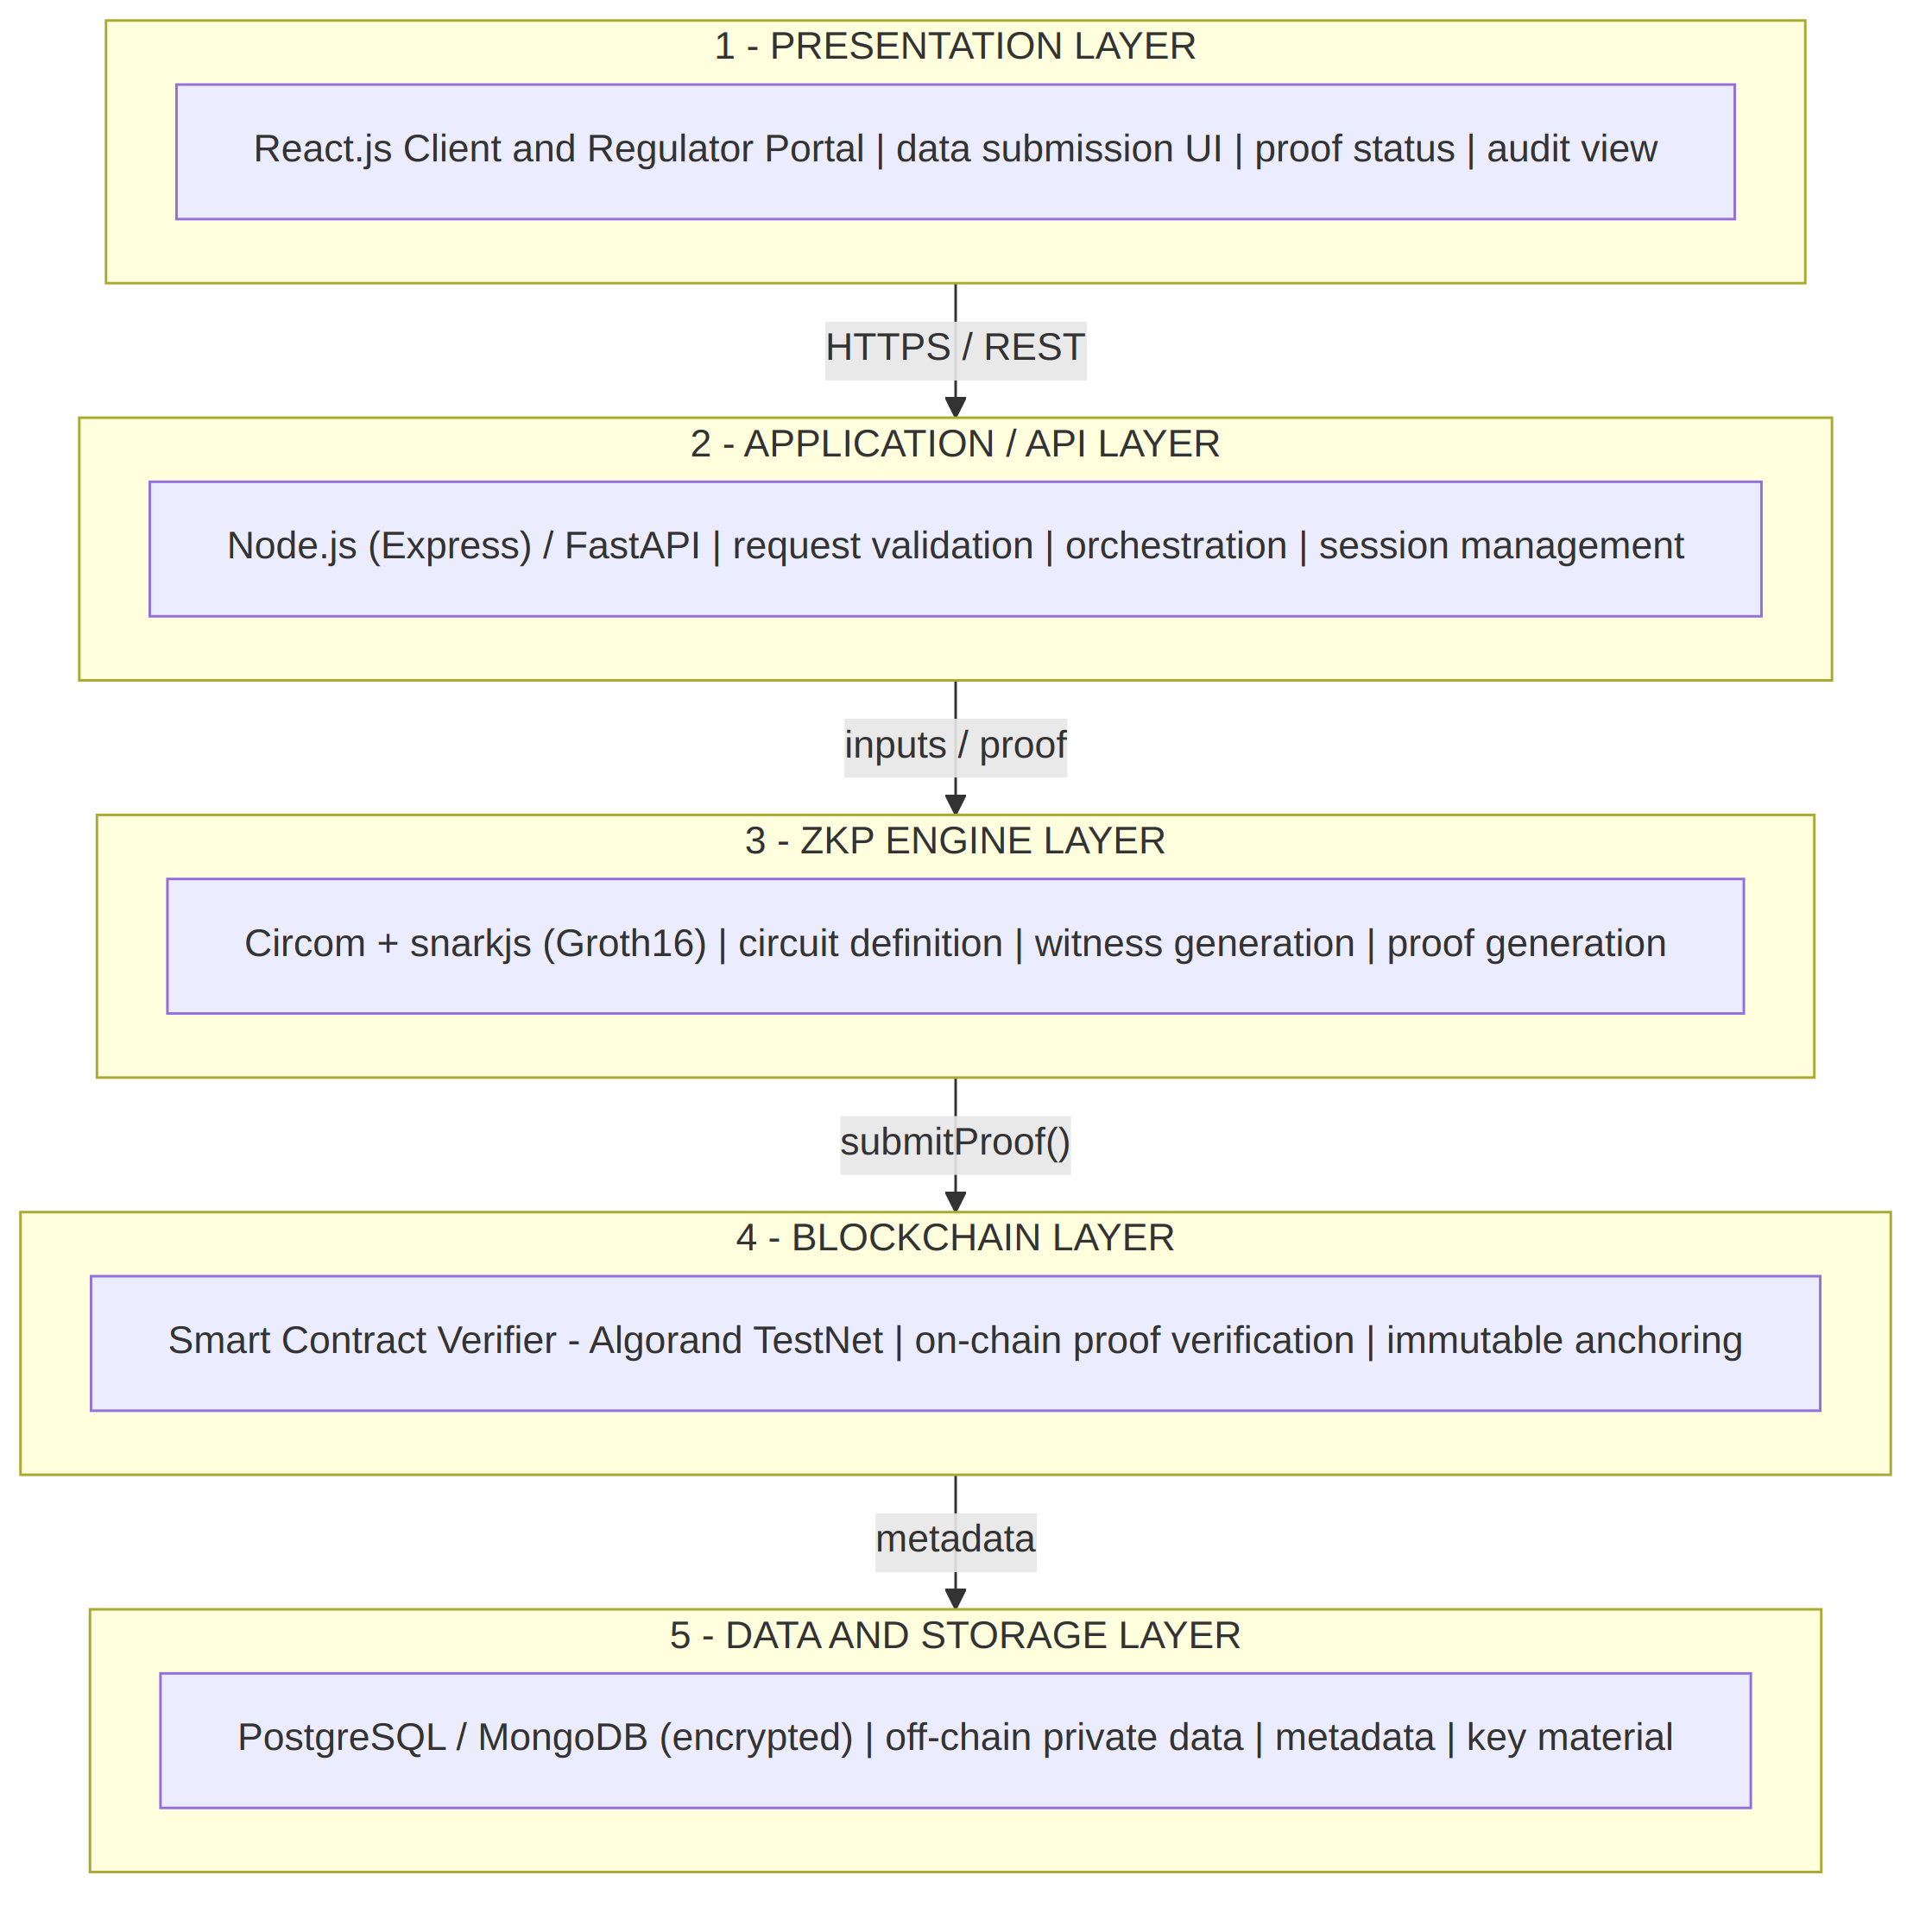

Figure 9.1: Five-layer system architecture
Layer | Technology | Responsibilities
1. Presentation | React.js client and regulator portal | Data-submission UI, proof status and audit view
2. Application / API | Node.js (Express) / FastAPI | Request validation, orchestration and session management
3. ZKP Engine | Circom + snarkjs (Groth16) | Circuit definition, witness generation and proof generation
4. Blockchain | Smart contract on Algorand TestNet | On-chain proof verification and immutable anchoring
5. Data and Storage | PostgreSQL / MongoDB (encrypted) | Off-chain private data, metadata and key material
Table 9.1: Layers of the system architecture

9.3 How the Layers Interact
1. The client submits a compliance request to the API layer over HTTPS.
2. The API layer builds the circuit inputs and invokes the ZKP engine.
3. The ZKP engine returns a zk-SNARK proof together with the public signals.
4. The API layer sends the proof to the blockchain verifier contract.
5. The contract verifies the proof and anchors the result on-chain.
6. The regulator or verifier reads the immutable on-chain attestation.

9.4 Architecture Component Explanation
Component | What it does | How it interacts
Client / Regulator Portal | Collects compliance requests; displays proof status and audit history | Calls the API layer over REST / HTTPS
API Gateway & Orchestrator | Validates input, builds circuit parameters and manages the proof workflow | Invokes the ZKP engine; reads and writes the off-chain database
ZKP Engine (Circom + snarkjs) | Encodes the compliance rule as an arithmetic circuit and generates a Groth16 proof | Returns proof and public signals to the orchestrator
Smart Contract Verifier | Performs the on-chain pairing check that validates the submitted proof | Receives the proof from the API layer; emits a verification event
Blockchain Ledger | Stores proof hash, timestamp and verification result immutably | Queried by the regulator dashboard for the audit trail
Off-chain Encrypted Store | Holds private data and metadata that must never reach the chain | Accessed only by the API layer under access control
Table 9.2: Architecture components and their interactions
Each component owns one responsibility and exposes a narrow, testable interface to its neighbours.

9.5 End-to-End Data Flow
Every request moves through eight traceable stages, from raw private data to a verifiable, privacy-preserving compliance result.
Stage | Name | Description
1 | Data Input | The data owner submits private compliance data (for example income, age or a transaction record).
2 | Preprocessing | The API layer validates the input and sets the public compliance threshold.
3 | Witness Generation | The ZKP engine computes a witness that satisfies the compliance circuit.
4 | Proof Generation | snarkjs derives a zk-SNARK proof (Groth16) using the proving key.
5 | Proof Submission | The proof and public inputs are sent to the blockchain verifier contract.
6 | On-chain Verification | The smart contract runs the pairing check to validate the proof.
7 | Ledger Anchoring | The verification result and proof hash are recorded immutably on-chain.
8 | Compliance Result | The regulator queries the chain and receives confirmation, with no raw data disclosed.
Table 9.3: Eight-stage end-to-end data flow
Traceability rule: every on-chain record links back to a proof hash and public inputs, but never to the underlying private data.

9.6 Data Flow Diagram Level 0
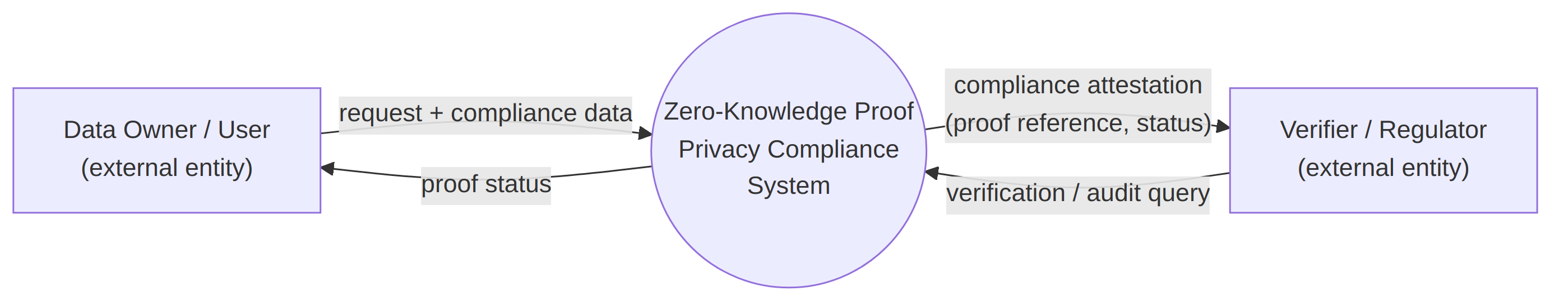
Figure 9.2: DFD Level 0 (context diagram)
Description: Outlines the external entities (Data Owner / User and Verifier / Regulator) that interact across the system boundary. The data owner supplies a request and compliance data and receives proof status; the regulator submits verification and audit queries and receives a compliance attestation.

9.7 Data Flow Diagram Level 1
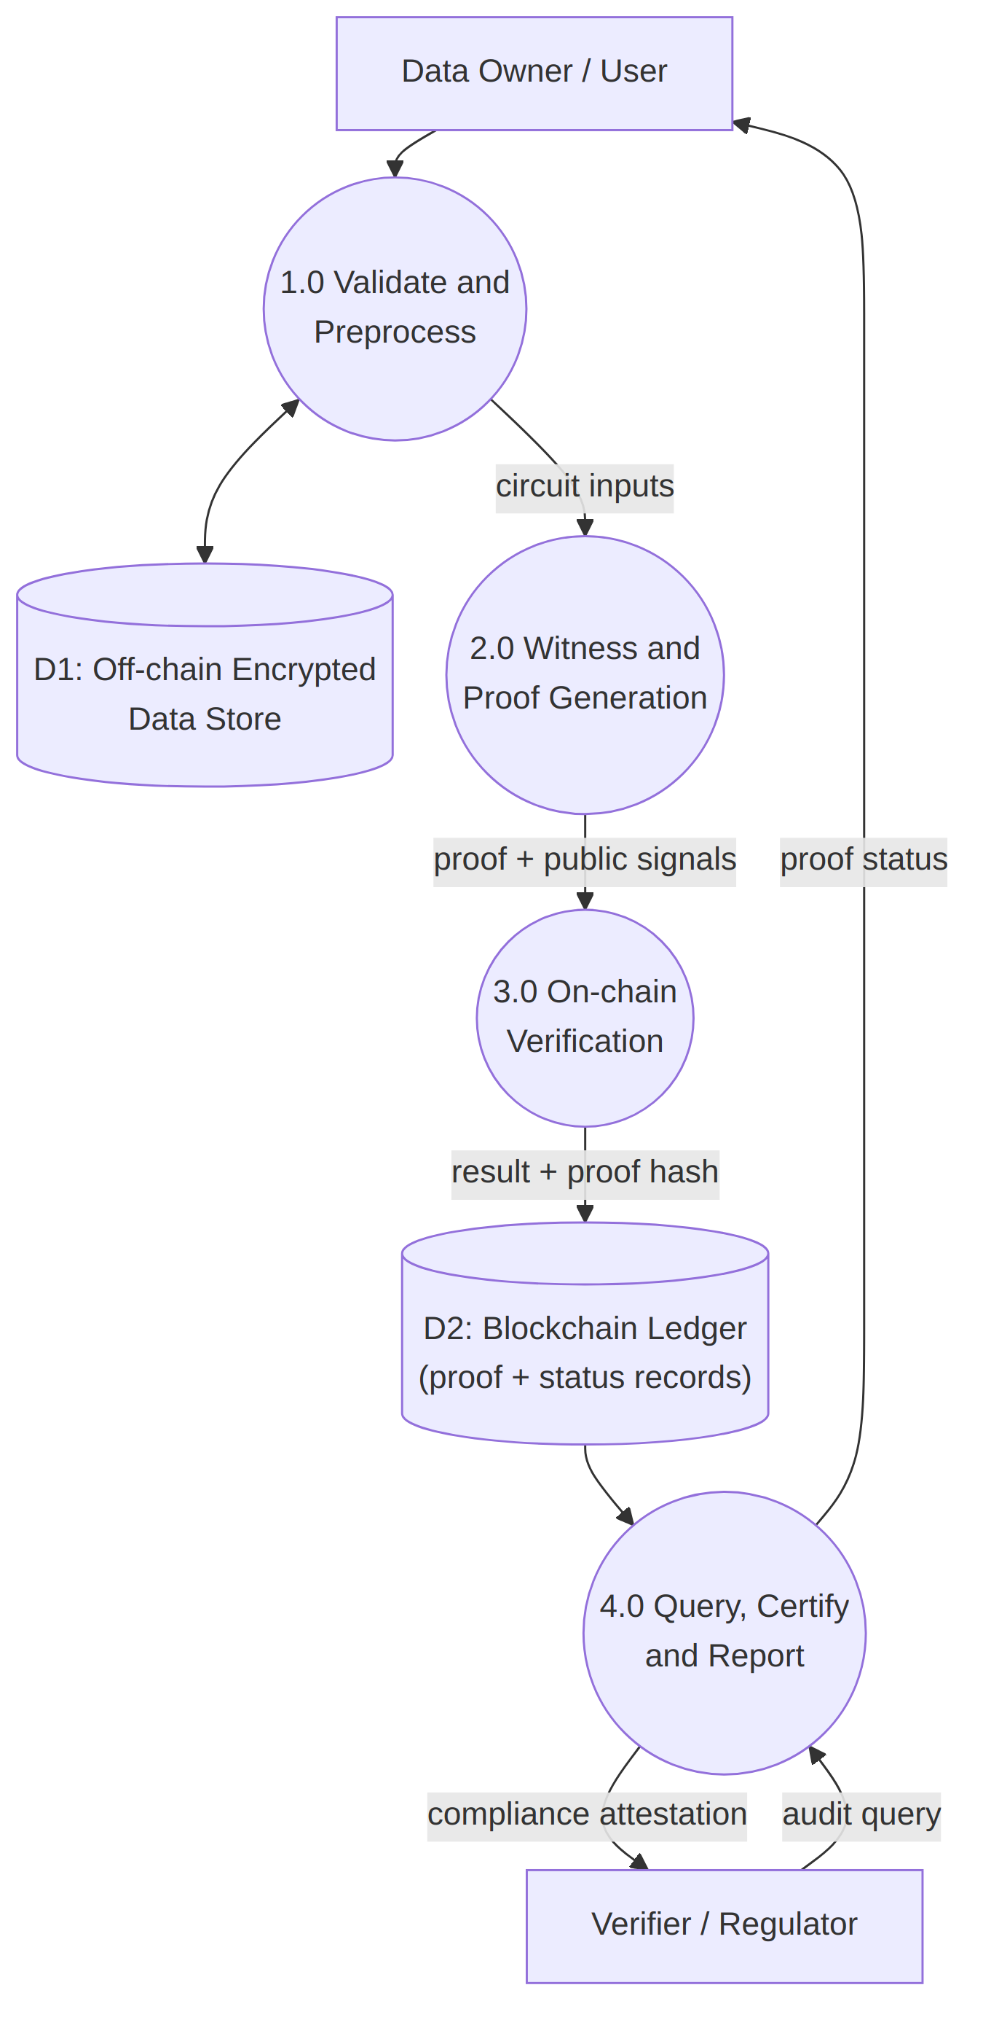
Figure 9.3: DFD Level 1 (decomposed process diagram)

CHAPTER 10: MODULES

10.1 Module Overview
The system is divided into four modules that communicate through explicit interfaces. This allows modules M1 to M4 to be built and unit-tested in parallel.
ID | Module | Key Responsibilities
M1 | Data Input & Preprocessing | Input validation, schema mapping, sensitive-field encryption, identifier hashing and consent-record handling
M2 | ZKP Circuit & Proof Generation | Circom circuit design, witness computation and Groth16 proof generation
M3 | Blockchain Smart Contract | Verifier contract, TestNet deployment, proof anchoring and event emission
M4 | Verification & Compliance Dashboard | Regulator dashboard, on-chain status query, audit-trail reporting, analytics and certificates
Table 10.1: Modules of the system

10.2 M1: Data Input and Preprocessing
M1 is the entry point of the pipeline. It accepts private compliance data from the data owner, validates mandatory fields and data types, and maps the input to the schema expected by the target compliance circuit. Sensitive fields are encrypted before they are written to the off-chain store, and personal identifiers are hashed so that raw identifiers are never stored unprotected. M1 also manages the consent lifecycle (capture, update, withdrawal and expiry) and sets the public compliance threshold that the circuit will check. Its output is a validated payload and a request ID that are passed to M2.

10.3 M2: ZKP Circuit and Proof Generation
M2 is the cryptographic core. Each compliance rule is implemented as a Circom circuit that distinguishes private inputs from public signals. For a request, M2 computes a witness that satisfies the circuit and then uses snarkjs to derive a Groth16 proof with the proving key. The module returns the proof and public signals to the orchestrator and can verify the proof locally before submission. Circuit unit tests check that valid claims produce accepting proofs and that invalid claims cannot, and the circuit outputs are reviewed to confirm that no private input leaks through the public signals.

10.4 M3: Blockchain Smart Contract
M3 contains the verifier smart contract deployed on the Algorand TestNet. It receives a proof and its public inputs, performs the on-chain pairing check, and records the proof hash, timestamp and verification result on the ledger. It emits a verification event that the dashboard and other clients can observe. Because only hashes, public signals and results are stored on-chain, the ledger provides an immutable audit trail without exposing personal data.

10.5 M4: Verification and Compliance Dashboard
M4 is the regulator-facing layer. It allows authorized users to query the proof or transaction status on-chain, view the audit trail for an entity or date range, and see aggregated analytics of compliance activity. It issues blockchain-backed compliance certificates that reference the on-chain verification record. Access to the dashboard is controlled by role-based permissions, and the interface is designed so that a non-technical auditor can read the compliance result.

10.6 Module Interaction and Interface Contracts
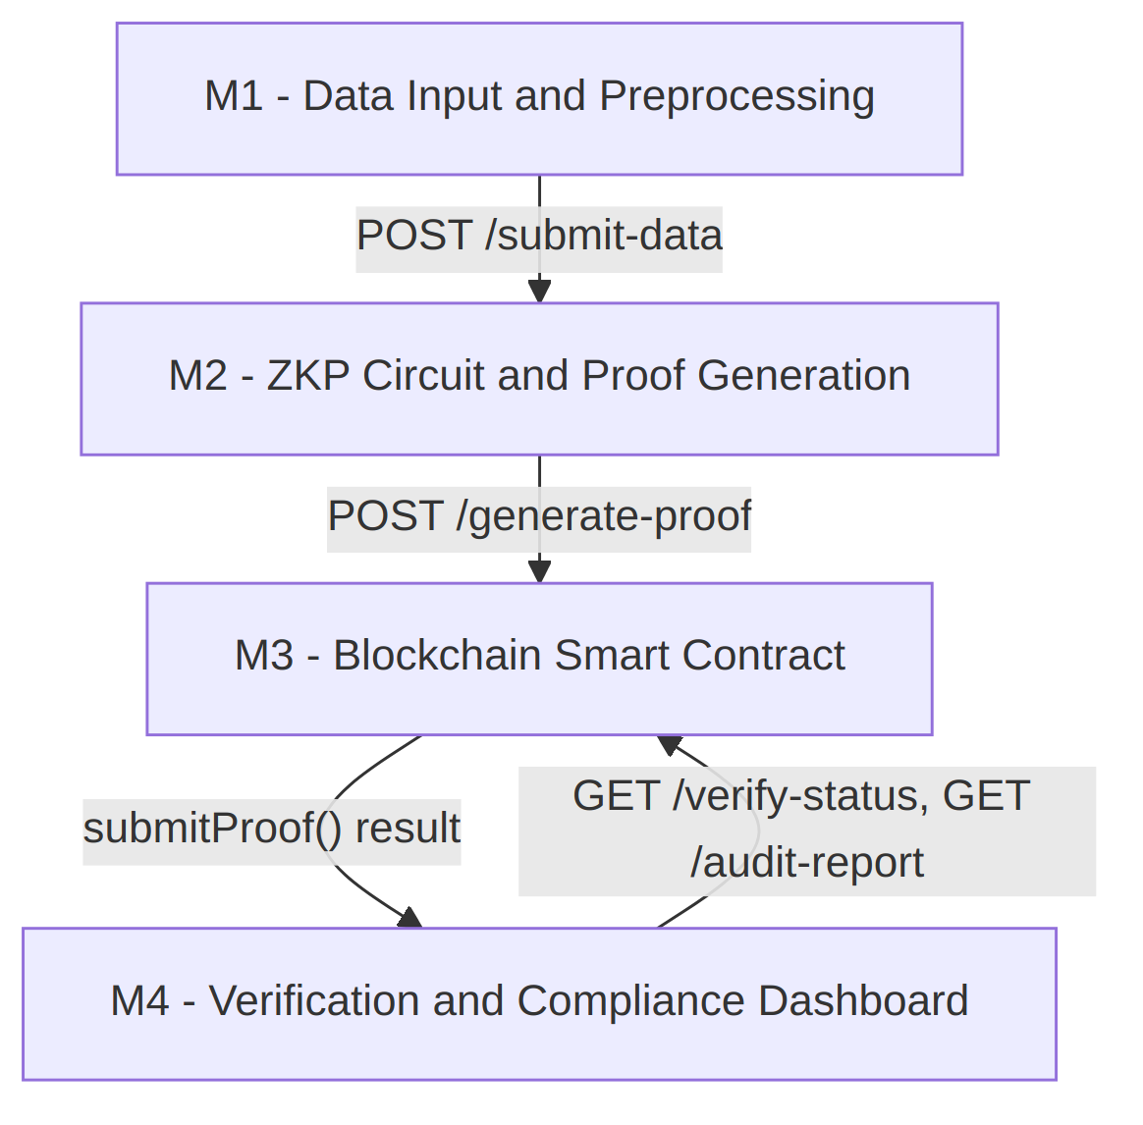
Figure 10.1: Module interaction and internal call sequence
Explicit interface contracts, listed in Table 10.2, let modules M1 to M4 be developed and tested in parallel.
Interface | Consumes | Returns
POST /submit-data | Private compliance data and user session | Validated payload and request ID
POST /generate-proof | Witness inputs and circuit parameters | zk-SNARK proof and public signals
submitProof() [contract] | Proof and public inputs | Verification boolean and on-chain event
GET /verify-status | Proof or transaction hash | Compliance status and audit reference
GET /audit-report | Entity ID or date range | Aggregated compliance report
Table 10.2: Interface contracts between modules

CHAPTER 11: UML DIAGRAMS
This chapter presents the UML models that describe the structure and behaviour of the system: use case, activity, sequence, class, component and deployment diagrams.

11.1 Use Case Diagram
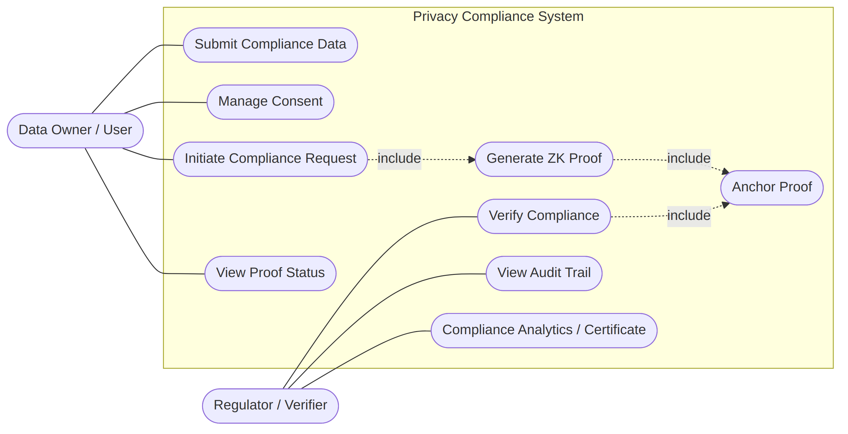
Figure 11.1: Use case diagram
Description: The Data Owner / User submits compliance data, manages consent, initiates compliance requests and views proof status. Generating the ZK proof and anchoring it on the blockchain are included in the compliance request. The Regulator / Verifier verifies compliance, views the audit trail and uses compliance analytics and certificates.

11.2 Activity Diagram
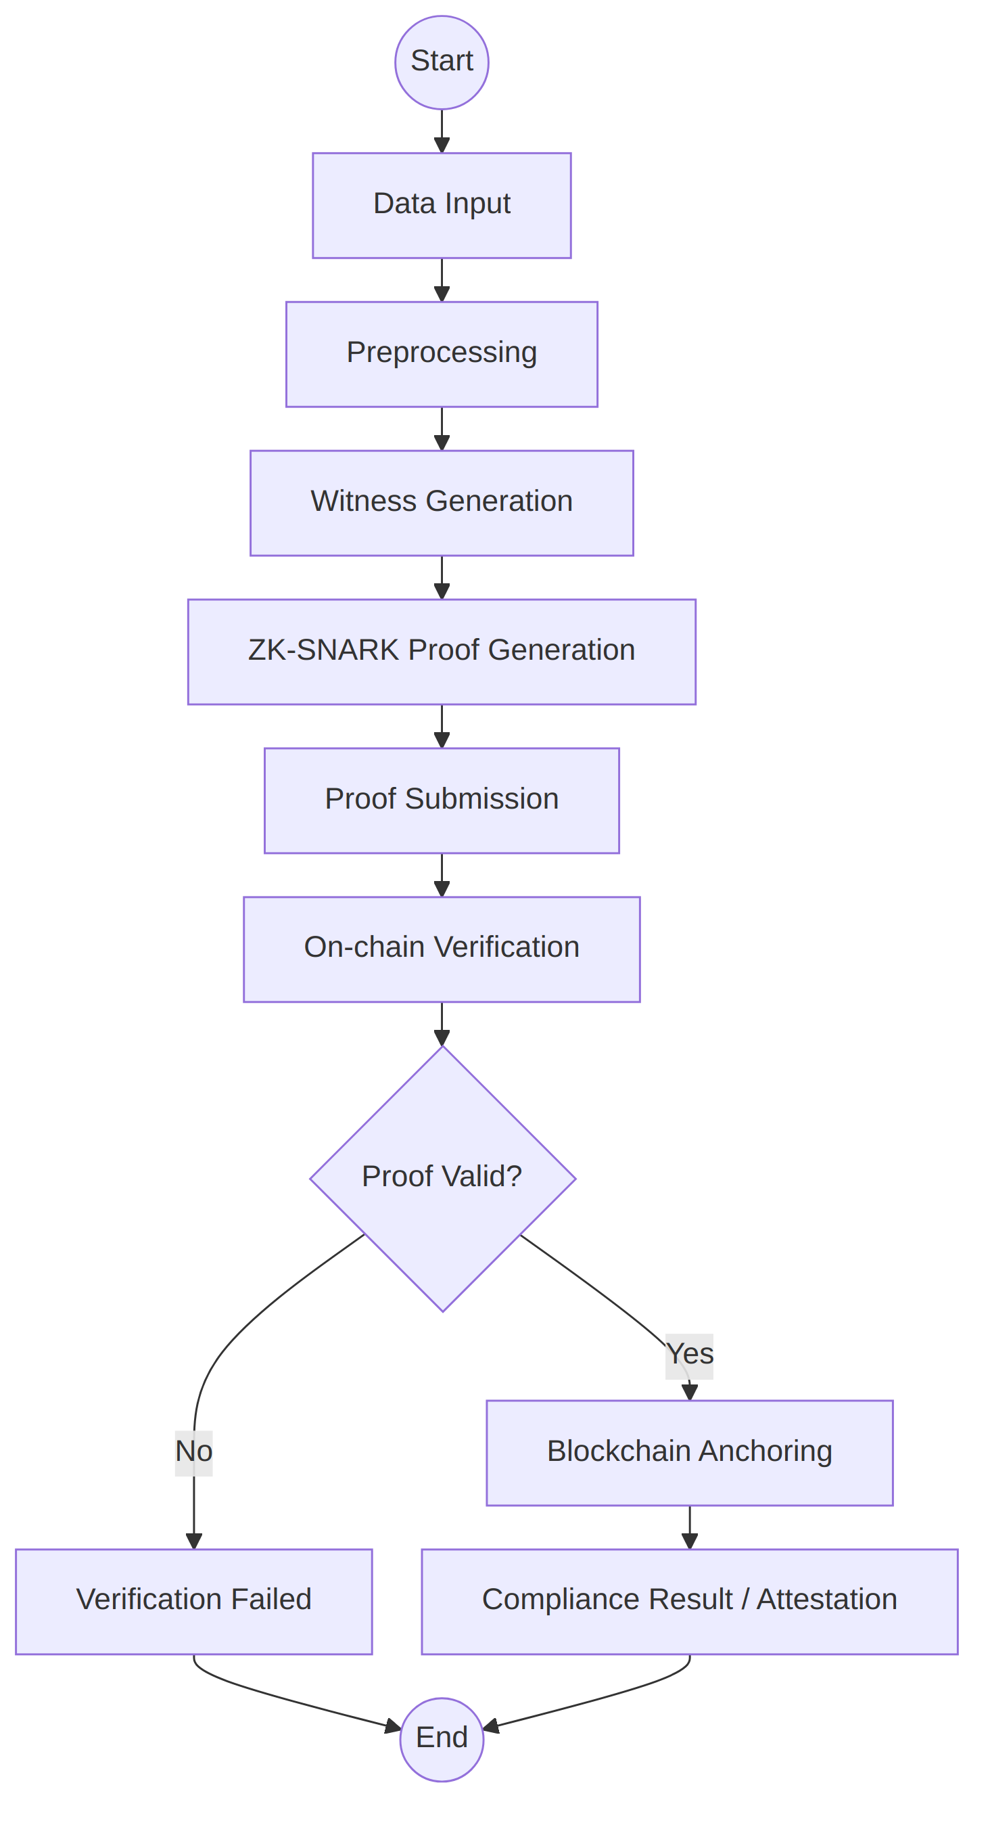
Figure 11.2: Activity diagram: compliance verification workflow
Description: Shows the control flow from data input through preprocessing, witness generation, zk-SNARK proof generation, proof submission and on-chain verification. A decision node checks whether the proof is valid: if valid, the proof is anchored on the blockchain and the compliance result or attestation is produced; if not, the flow ends with a verification failure.

11.3 Sequence Diagram
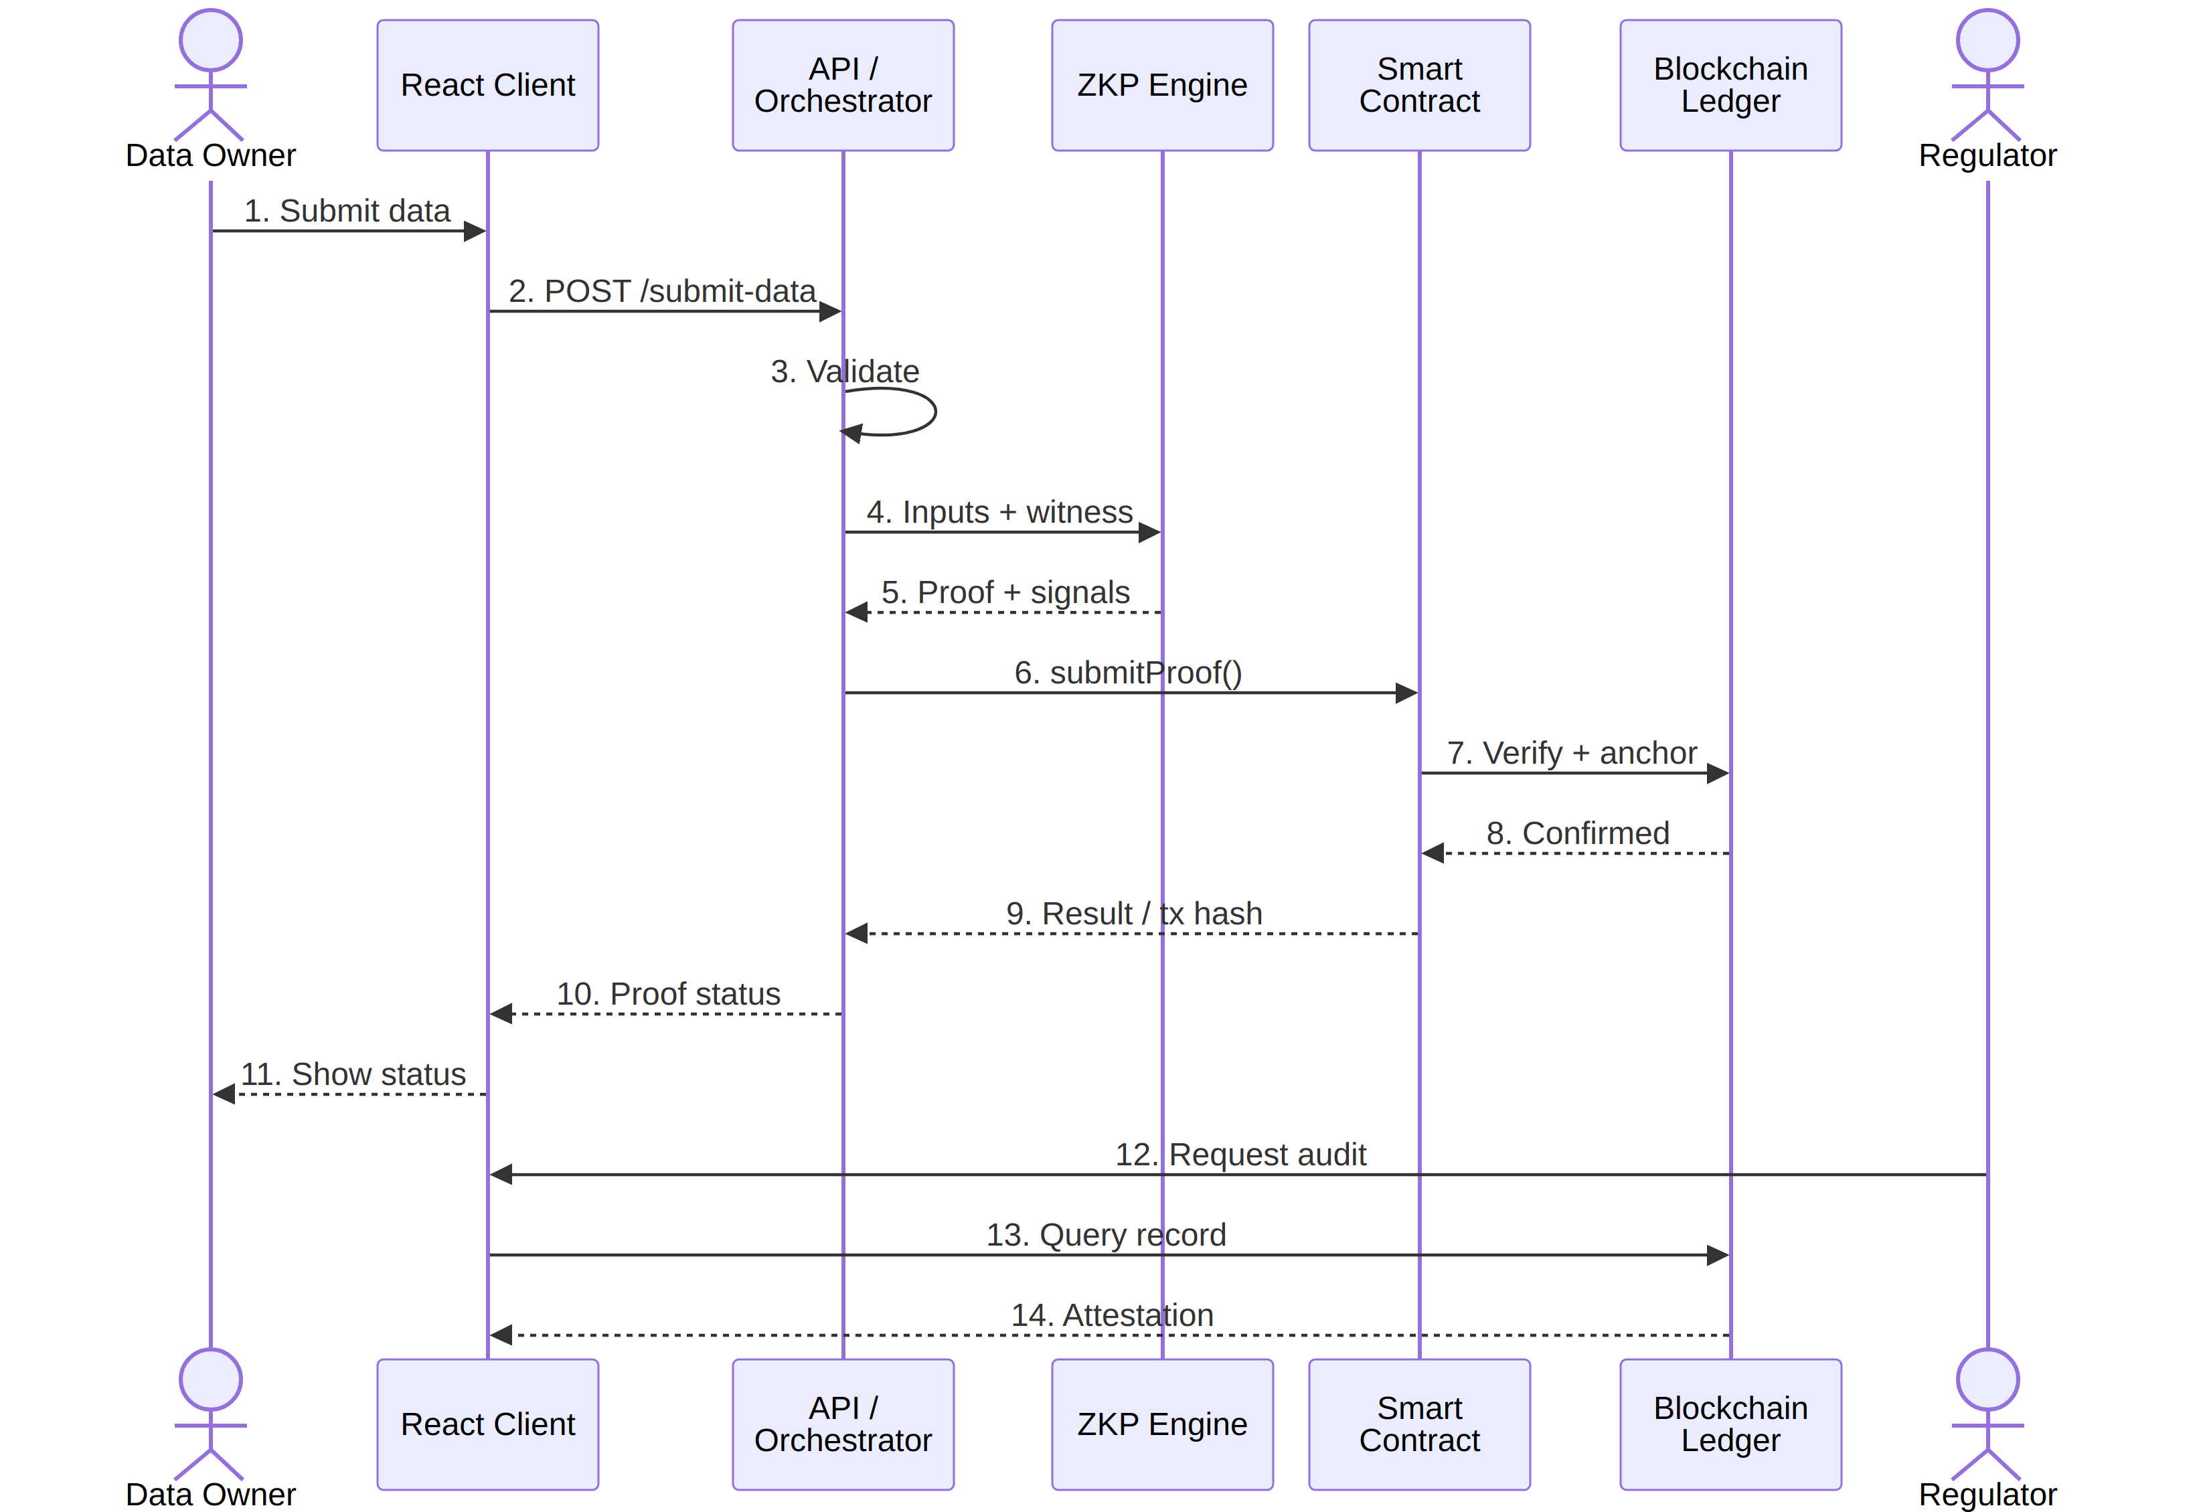
Figure 11.3: Sequence diagram: ZK compliance verification
Description: Shows the chronological message exchange among the Data Owner, React client, API / orchestrator, ZKP engine, smart contract, blockchain ledger and Regulator. The owner submits data (POST /submit-data), the orchestrator builds the witness and obtains the proof, submitProof() is called on the contract, the result is anchored on the ledger and the proof status returns to the owner. The regulator later requests verification and receives the compliance attestation from the on-chain record.

11.4 Class Diagram
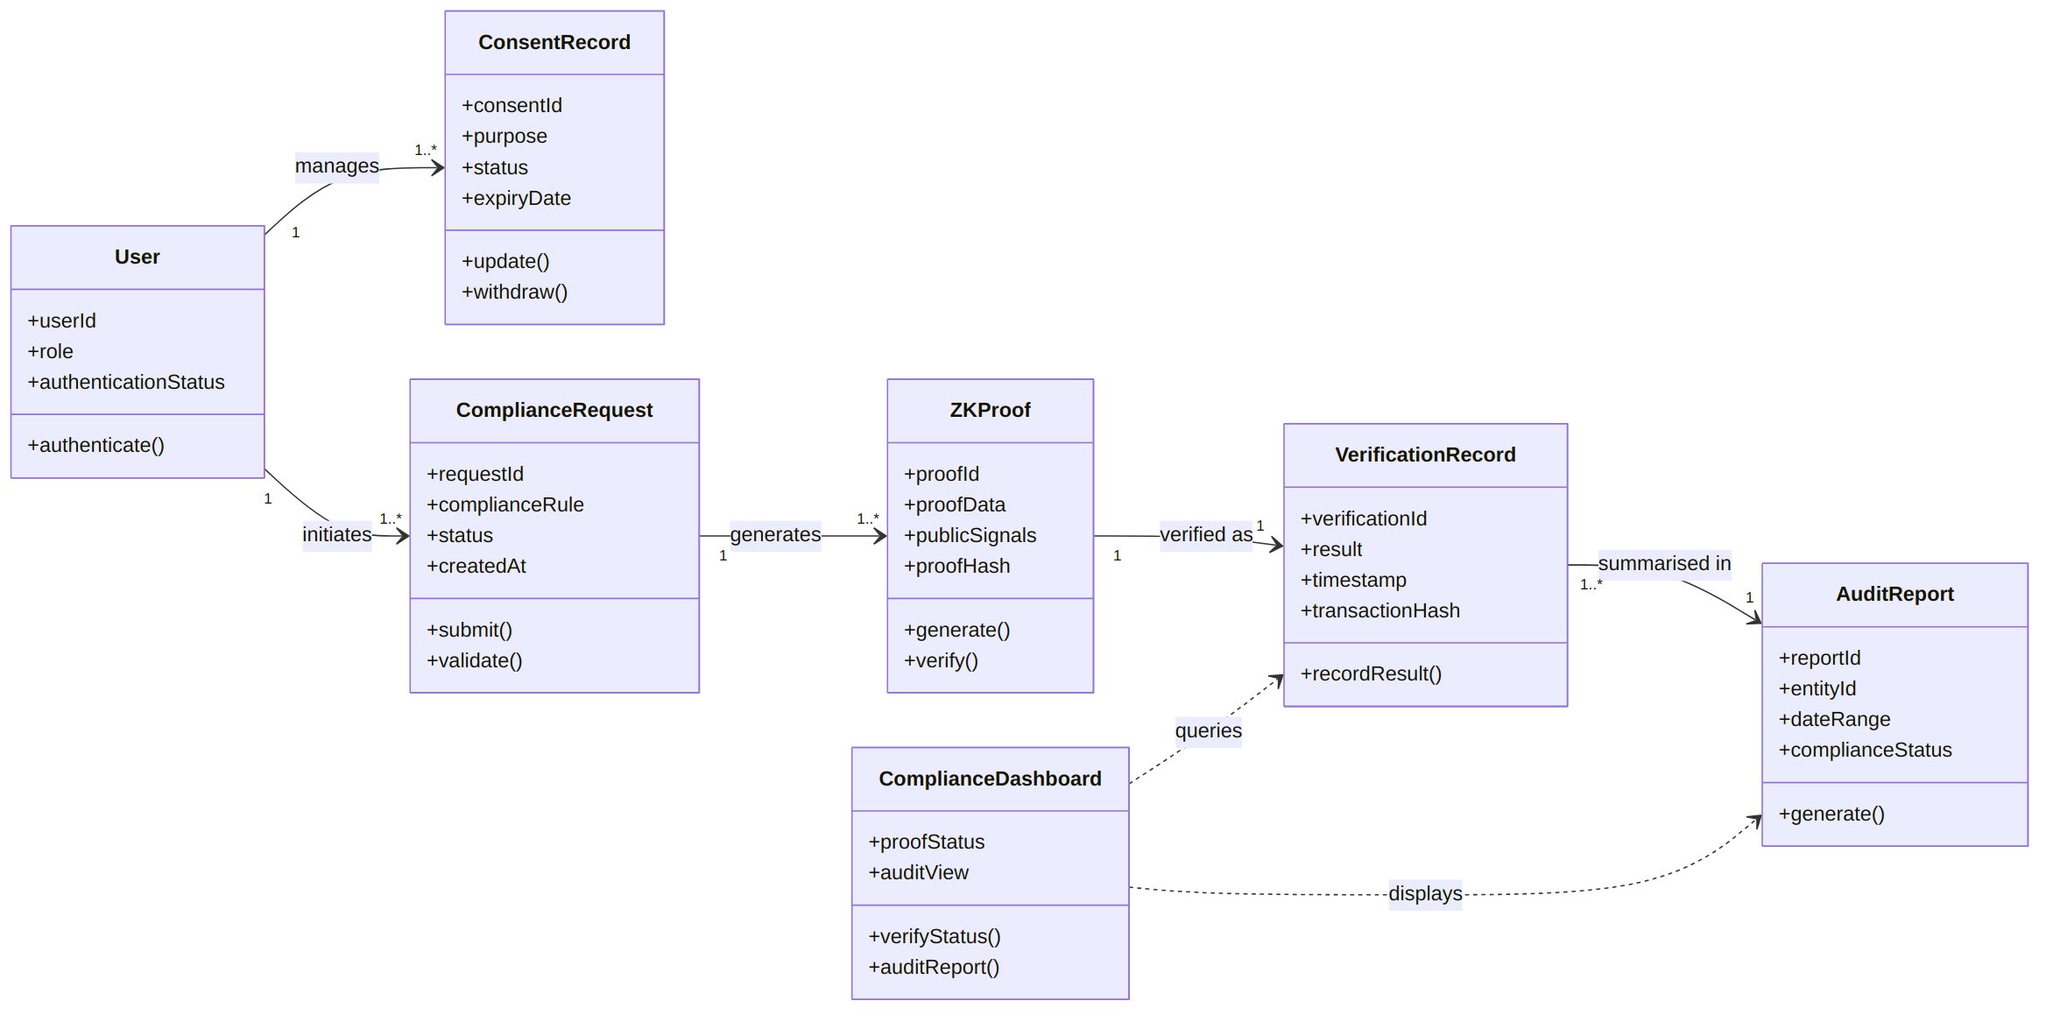
Figure 11.4: Class diagram: core domain model
Description: Captures the core domain model. A User manages consent records and initiates compliance requests; each ComplianceRequest generates one or more ZKProof objects; each proof is recorded as a VerificationRecord that holds the result, timestamp and transaction hash; and AuditReport summarizes verification records for an entity and date range. The ComplianceDashboard queries verification records and displays audit reports.
Class | Responsibility
User | Represents a data owner or regulator with a role and authentication status; authenticates to the platform
ConsentRecord | Holds consent purpose, status and expiry date; supports update and withdrawal
ComplianceRequest | Holds the compliance rule, status and creation time; submits and validates the request
ZKProof | Holds proof data, public signals and proof hash; generates and verifies the proof
VerificationRecord | Holds the verification result, timestamp and transaction hash; records the result on-chain
AuditReport | Aggregates compliance status for an entity over a date range
ComplianceDashboard | Presents proof status and audit views; exposes verifyStatus() and auditReport()
Table 11.1: Classes of the domain model and their responsibilities

11.5 Component Diagram
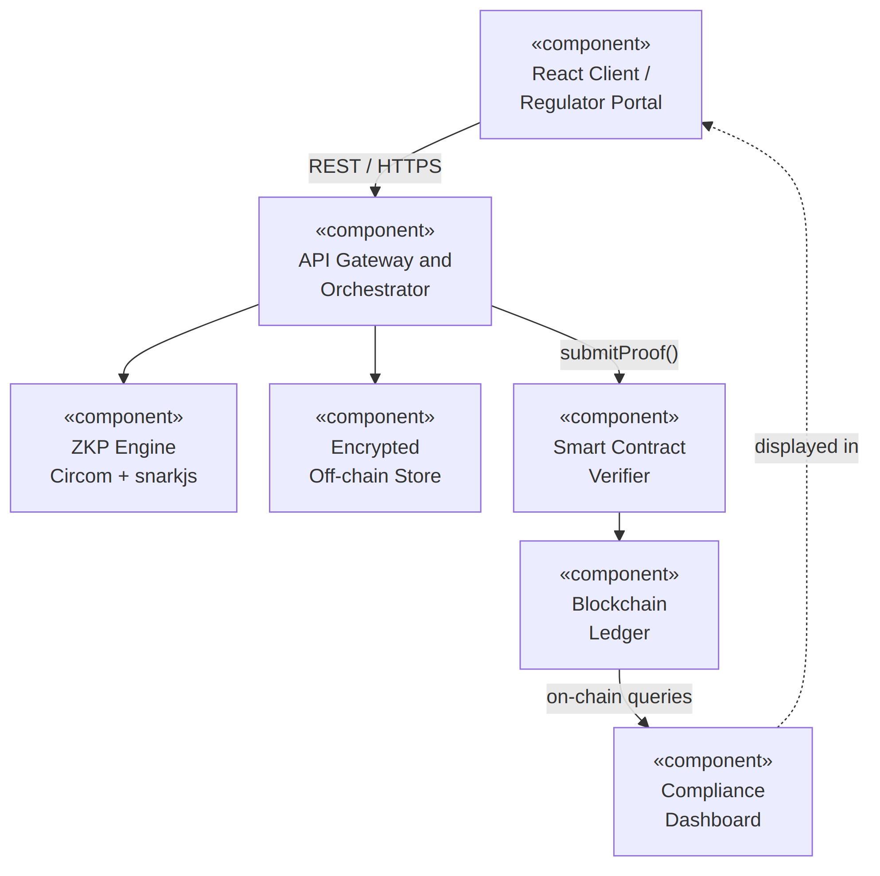
Figure 11.5: Component diagram: system components
Description: Illustrates high cohesion and loose coupling between the React client or regulator portal, the API gateway and orchestrator, the ZKP engine (Circom and snarkjs), the smart contract verifier, the blockchain ledger, the encrypted off-chain store and the compliance dashboard.

11.6 Deployment Diagram
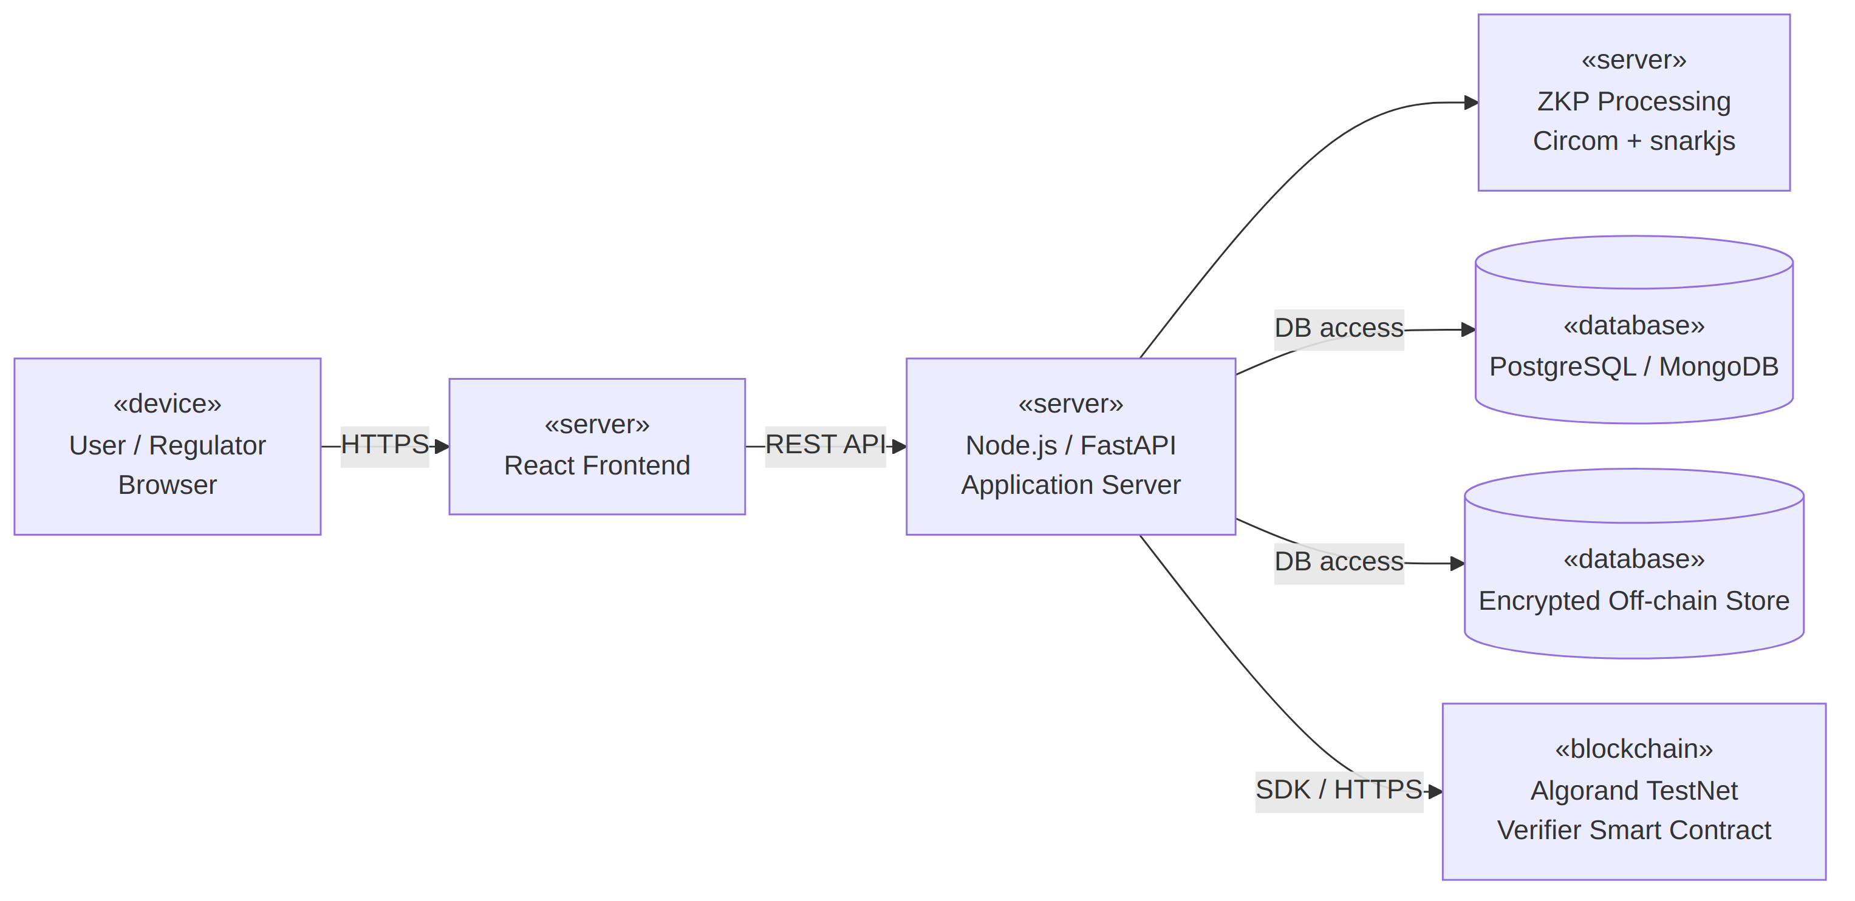
Figure 11.6: Deployment diagram: system deployment
Description: Represents the physical and execution environment. The user or regulator browser reaches the React frontend over HTTPS; the frontend calls the Node.js / FastAPI application server through a REST API; the application server uses the ZKP processing node (Circom and snarkjs), accesses the PostgreSQL / MongoDB and encrypted off-chain stores, and interacts with the verifier smart contract on the Algorand TestNet.

